**BUFFER ISSUE RESOLUTION DOCUMENT (BIRD)**

**ISSUE TITLE:** *AMI Touchstonefile ® Analog Buffer Models*

**REQUESTOR:**  *Walter Katz, Signal Integriity Software, Inc.*

*Todd Westerhoff, Signal Integrity Software, Inc.*

*Fangyi Rao, Keysight Technologies, Inc.*

**DATE SUBMITTED:** February 20, 2013, May 15, 2013; May 17 2013; May 24, 2013

**ANALYSIS PATH/DATA THAT LED TO SPECIFICATION:**

The IBIS 5.1 specification provides limited capability for describing the frequency-dependent behavior of a SerDes transmitter’s analog output driver or receiver’s analog input termination network. This makes it difficult to model a device’s insertion and return loss accurately, both of which are key factors in determining Inter-Symbol Interference (ISI) and overall signal quality. This BIRD assumes that the Tx analog output and Rx termination network are described using 4 port S-parameter data and that the .s4p data is developed in a manner consistent with the subcircuits and parameters defined below. The subcircuits used to instantiate the transmitter and receiver on-die S-parameters are shown on the following pages. These subcircuits are treated as standard templates that are used whenever the AMI parameters defined in this document are used in the .ami file. This BIRD defines new AMI Reserved Parameters Tstonefile, Tx_V, Tx_R, Rx_R.

**ANY OTHER BACKGROUND INFORMATION:**

# Transmitter Driver Analog Circuit

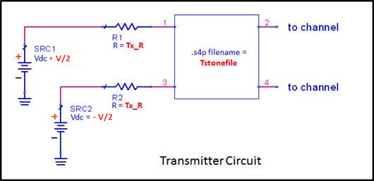

The Step Response Stimulus is a differential waveform which switches SRC1 and SRC2 synchronously from a logic level 0 to a logic level 1.

V = Tx_V for logic 1 and –Tx_V for logic 0

Transition time between 1 and 0 in the two ideal voltage sources is zero

Pin order: 1->2, 3->4 (from Tx to channel)

When logic level is 1, V(SRC1,SRC2)=Tx_V

When logic level is 0, V(SRC1,SRC2)=-Tx_V

# Receiver Analog Termination Circuit

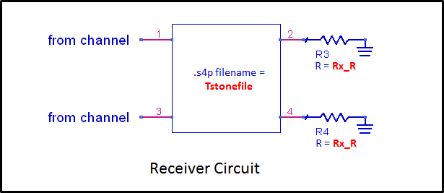

Voltage difference between ports 2 and 4 is the differential input to the Rx algorithmic model.

The IBIS AMI flow requires that the EDA tool generate an Impulse Response of the channel. This Impulse Response characterizes the differential response of the Tx analog buffer model, the Tx package model, the interconnect between the Tx component and the Rx component, the Rx package model and the Rx analog buffer model. The Touchstone file defined here BIRD is to be used for either the Tx analog buffer and/or the Rx analog buffer model. Note that when the Reserved Parameter Tstonefile is defined in the AMI model the Touchstone file is to be used in lieu of the analog buffer model in the [Model] section. The [Model] may also have IV and VT curves and may also have an [External Model] defined, however they are not used when the Reserved Parameter Tstonefile is defined in the .ami file. For Tx models that have the Reserved Parameter Tstonefile, the Reserved Parameter Tx_V is required and the Reserved Parameters Tx_R are optional. For Rx models that have the Reserved Parameter Tstonefile, the Reserved Parameter Rx_R is optional. For a Tx buffer, the Transmitter Circuit defines the analog buffer model between the zero impedance stimulus input voltage source and the die side of the package model. For an Rx buffer, the Receiver Circuit defines the analog buffer model between the die side of the package model and a high impedance probe at the input to the Rx Algorithmic model. Note that this Touchstone analog model represents the on-die model between the die pad and buffer interface to the algorithmic model, and therefore the package model must be included between the die pad and the component pin. The on-die model includes both on-die interconnect and the analog buffer model. Given that the Touchstone buffer model, package interconnect model and interconnect between the Tx and Rx component pin are LTI there are many methods of generating an Impulse Response of the channel to be used in AMI modeling that will give the identical result within numerical accuracy of the technique chosen. One technique commonly used in EDA tool simulation is to generate a Step Response Simulation by applying a step excitation and calculating the time derivative of the step response. A step excitation (Step Response Stimulus) is defined when the Tstonefile parameter is present. The Channel Step Response is measured with a high impedance differential probe between ports 2 and 4 of the Rx Touchstone file. The Impulse Response of the channel to be used as the input to the Tx AMI_Init function is the time derivative of this Channel Step Response.

## Reserved Parameter DEFINITIONs

*Parameter:* **Tstonefile**

*Required:* No

*Descriptors*:

Usage: Info and Dep

Type: String

Format: Value, List, Corner

Default: <String literal>

Description:<String >

*Definition:* This parameter contains the name of the .s4p file to be used in the Analog Model Circuit. The .s4p can be measured at any reference impedance. See the Analog Circuit Definitions above for the pin order associated with the .s4p file.

*Examples:*

(Tstonefile (Usage Info)(Type String)(Corner “typ.s4p” “min.s4p” “max.s4p”))

*Parameter:* **Tx_V**

*Required:* Yes, if IBIS [Model] declarations of type Output or Output_diff and **Tstonefile** is defined.

*Descriptors*:

Usage: Info and Dep

Type: Float

Format: Value, List, Corner, Range, Increment, Steps

Default: <numeric_literal>

Description:< String >

*Definition:* This parameter defines the voltage swing of the stimulus input to the input to the transmitter circuit.

*Examples:*

(Tx_V (Usage Info)(Type Float)(Range 1. .5 1.))

*Parameter:* **Tx_R**

*Required:* No

*Descriptors*:

Usage: Info and Dep

Type: Float

Format: Value, List, Corner, Range, Increment, Steps

Default: <numeric_literal>

Description:<string>

*Definition:* This parameter is optional and defines the value of the Tx_R series resistor in ohms. It only applies to IBIS [Model] declarations of type Output or Output_diff. If not present in the .ami file, the value of Tx_R defaults to zero.

*Examples:*

(Tx_R (Usage Info)(Type Float)(Value 0.0))

*Parameter:* **Rx_R**

*Required:* No

*Descriptors*:

Usage: Info and Dep

Type: Float

Format: Value, List, Corner, Range, Increment, Steps

Default: <numeric_literal>

Description:<string>

*Definition:* This parameter is optional and defines the value of Rx_R in ohms. It only applies to IBIS [Model] declarations of type Input or Input_diff. If not present in the .ami file, the value of Rx_R defaults to infinity, or a reasonable approximation thereof.

*Examples:*

(Rx_R (Usage Info)(Type Float)(Value 1.0e6))